The Deep Dark Web Lab

Ryan Coon

CYB-505

Professor Devin Ogg

September 4, 2024

Part 1:

Screenshots:

Screenshot of the TOR browser installed and running

Hidden Wiki Dark Web links

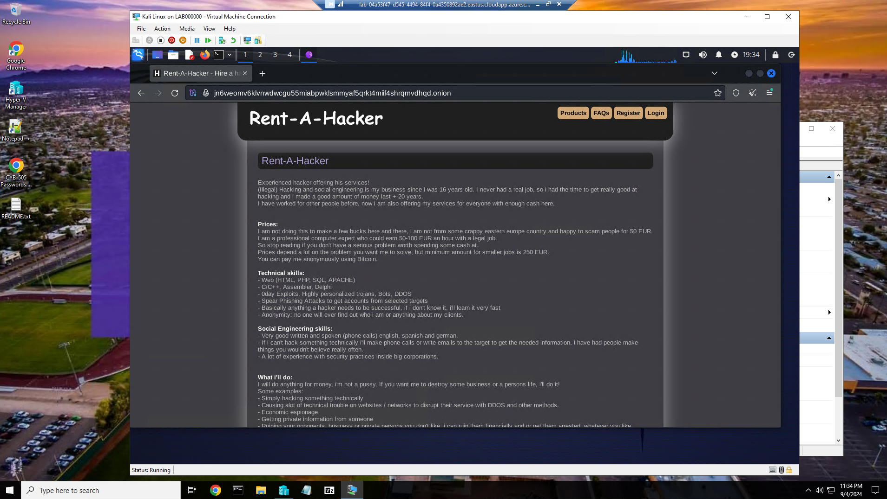

Rent-A-Hacker/Hacker for Hire dark web store

Part 2:

Preface

Cyber Threat Intelligence (CTI) refers to the collection, analysis, and dissemination of information regarding potential or existing threats to an organization’s digital assets. It encompasses a broad range of data, including:

Indicators of Compromise (IoCs): Artifacts observed on a network or in operating system files that suggest a breach.

Tactics, Techniques, and Procedures (TTPs): The behavior and methods used by threat actors to infiltrate systems.

Vulnerabilities: Weaknesses in software, hardware, or configurations that can be exploited by attackers.

CTI can be categorized into three main types:

Strategic Intelligence: High-level insights that help organizations understand the threat landscape, often used for long-term planning.

Operational Intelligence: Information that informs immediate actions against ongoing threats, focusing on specific campaigns or actors.

Tactical Intelligence: Detailed data that provides organizations with actionable steps to mitigate specific threats.

Why is Cyber Threat Intelligence Important?

The importance of Cyber Threat Intelligence cannot be overstated. Here are several reasons why it plays a critical role in modern cybersecurity:

Proactive Defense: CTI enables organizations to anticipate and prepare for potential attacks before they occur, rather than merely reacting to incidents. This proactive approach can significantly reduce the impact of a breach.

Informed Decision-Making: By understanding the specific threats that an organization faces, decision-makers can allocate resources more effectively, prioritize cybersecurity efforts, and implement targeted defenses.

Enhanced Incident Response: When a breach occurs, CTI provides the context necessary for a swift and effective response. It helps security teams to identify the nature of the threat and the appropriate remediation steps.

Risk Management: CTI assists organizations in understanding their risk exposure by providing insights into threats relevant to their industry and operational environment. This enables better risk assessment and management strategies.

Collaboration and Sharing: CTI fosters collaboration between organizations and sectors, allowing for the sharing of threat information. This collective intelligence can lead to stronger defenses across the board.

Regulatory Compliance: Many industries are subject to regulatory requirements regarding cybersecurity. Implementing CTI can help organizations meet these requirements by demonstrating a proactive approach to threat management.

In conclusion, Cyber Threat Intelligence is a vital component of an effective cybersecurity strategy. By gathering and analyzing relevant data, organizations can strengthen their defenses, respond more effectively to incidents, and ultimately protect their assets and reputation in an increasingly complex cyber landscape. The investment in CTI not only enhances security posture but also supports overall business resilience in the face of evolving threats.

**Hacker for Hire: Cybercrime or Cyber-Assisted Crime?**

A hacker for hire typically engages in illegal activities such as:

Data breaches: Unauthorized access to databases or systems to steal information.

DDoS attacks: Overwhelming a target's online services to disrupt operations.

Phishing schemes: Deceiving individuals to reveal personal information.

Given these actions, hiring a hacker primarily constitutes a cybercrime. The act of hacking itself is illegal, regardless of whether it is done for personal gain or on behalf of another party.

Cybercrime:

Engages directly with digital platforms or systems.

Involves actions that are illegal in themselves, such as unauthorized access or data theft.

Cyber-Assisted Crime:

Involves traditional criminal activities that are facilitated by digital methods.

The base crime might be legal without the technological element, such as planning a burglary using social media.

In summary, hiring a hacker primarily represents cybercrime due to the inherently illegal actions performed by the hacker. In contrast, cyber-assisted crimes involve traditional crimes that leverage technology for facilitation. Understanding these distinctions is crucial for effectively addressing and prosecuting various forms of criminal activity in today's digital landscape.

References:

Alvarez, R. (2021, September 2). Cyber Enabled Crime vs. Cyber Dependent Crime – IP PROBE – Blog. Ipprobe.global. https://ipprobe.global/2021/09/02/cyber-enabled-crime-vs-cyber-dependent-crime/

Baker, K. (2023, March 23). What is Cyber Threat Intelligence? [Beginner’s Guide]. Crowdstrike.com; Crowdstrike. https://www.crowdstrike.com/cybersecurity-101/threat-intelligence/

Cyber Choices - National Crime Agency. (n.d.). Www.nationalcrimeagency.gov.uk. https://www.nationalcrimeagency.gov.uk/cyber-choices#:~:text=Cyber%2Denabled%20crime%20is%20where

EC-Council. (2024, March 7). What is Cyber Threat Intelligence | Cyber Threat Intelligence Analyst | Types of Threat Intelligence | EC-Council. Cybersecurity Exchange. https://www.eccouncil.org/cybersecurity-exchange/threat-intelligence/what-is-cyber-threat-intelligence/

Information Technology and Ethics/Cyber-Crimes - Wikibooks, open books for an open world. (n.d.). En.wikibooks.org. https://en.wikibooks.org/wiki/Information_Technology_and_Ethics/Cyber-Crimes

Phillips, K., Davidson, J. C., Farr, R. R., Burkhardt, C., Caneppele, S., & Aiken, M. (2022). Conceptualizing cybercrime: Definitions, typologies and taxonomies. Forensic Sciences, 2(2), 379–398. mdpi. https://doi.org/10.3390/forensicsci2020028

What is Cyber Threat Intelligence? (2015, October 26). CIS. https://www.cisecurity.org/insights/blog/what-is-cyber-threat-intelligence